Chapter 4 Introduction Activity
Skeleton Towers

A “Skeleton Tower” is a structure in the illustrated form, with a center column of height n and four fins coming off of each face of the spine.
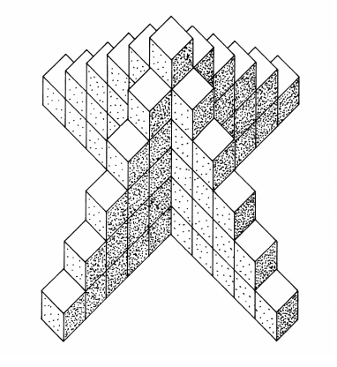

Working in groups, using the unit blocks to assist you, answer the following questions.

1. How many cubes are needed to build a skeleton tower whose center column is 4 cubes high?

2. How many cubes are needed to build a skeleton tower whose center column is 6 cubes high?

3. How many cubes are needed to build a skeleton tower whose center column is 12 cubes high? Explain how you figure out your answer.

4. How many cubes would be needed to build a skeleton tower whose center column is n cubes high? Make a rule that defines the total number of cubes a_{n} needed to build a tower where the center column is n cubes high. Using a large post-it to prepare a poster that presents your rule and HOW your group found it. Be sure to articulate the most fascinating patterns or rules that you discovered. Your group will be given 5 minutes to present this rule to the class.

