Name: ___________________________________________

Problem Set 3.1

1- 2] Find the missing side lengths of the given right triangles. Then find the area and perimeter of each triangle.
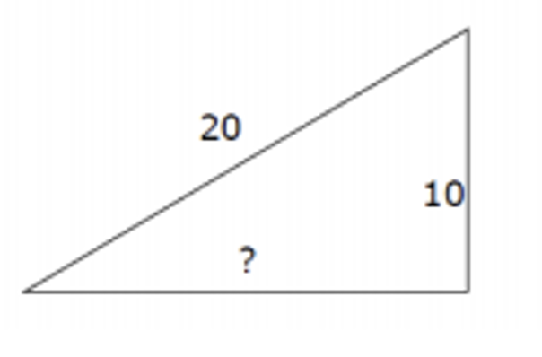
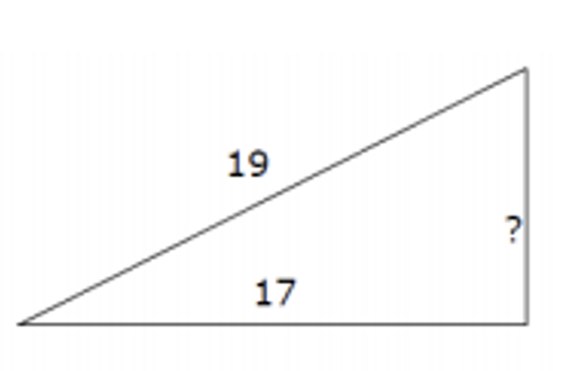
1.) 2.)

3 – 4] For the following let a and b be the legs of a right triangle and c be the hypotenuse of a right triangle. Find the missing side.

3.) a = 12 b = 5 c = ____________________

4.) a = 8 b = __________________ c = 10

5.) To get from point A to point B you must avoid walking through a pond. To avoid the pond, you must walk 34 meters south and 41 meters east. To the nearest meter, how many meters would be saved if it were possible to walk through the pond?

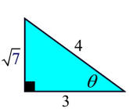
6.) Evaluate the six trigonometric functions for the angle below.

7 - 12] Find the length of each missing side denoted by a variable.
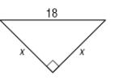
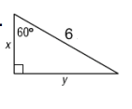
7.) 8.)

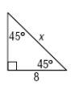
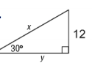
x = _________________ y = ________________ x = _________________

9.) 10.)

x = _________________ y = ________________ x = _________________

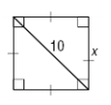
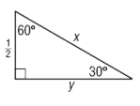
11.) 12).

x = _________________ y = ________________ x = _________________

13.) If , evaluate

14.) Consider the special right triangles below. Evaluate the six trigonometric functions for the 30º angle and the 60º angle. Do you recognize anything?
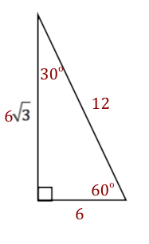
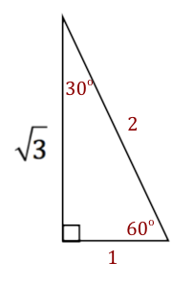

sin(30º) = csc(30º) = sin(30º) = csc(30º) =

cos (30º) = sec(30º) = cos(30º) = sec(30º) =

tan(30º) = cot(30º) = tan(30º) = cot(30º) =

sin(60º) = csc(60º) = sin(60º) = csc(60º) =

cos (60º) = sec(60º) = cos(60º) = sec(60º) =

tan(60º) = cot(60º) = tan(60º) = cot(60º) =

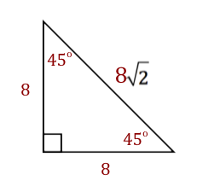
15.) Consider the special right triangles below. Evaluate the six trigonometric functions for the 45º angle. Do you recognize anything?
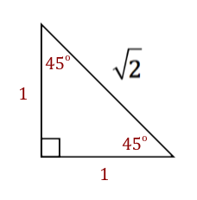

sin(45º) = csc(45º) = sin(45º) = csc(45º) =

cos (45º) = sec(45º) = cos(45º) = sec(45º) =

tan(45º) = cot(45º) = tan(45º) = cot(45º) =

16 - 21] Solve the following problems using trigonometry. Show all of your work on a separate sheet of paper .

16.) A helicopter flies horizontally at 100 km/hr. An observer notices that it takes 20 seconds for the helicopter to fly from directly overhead to being at an angle of elevation of 60º. How high above the ground is the helicopter?

17.) A person is 200 yards from a river. Rather than walk directly to the river, the person walks 400 yards along a path diagonal to the river’s edge. Find the acute angle between this path and the river’s edge.

18.) A photographer points a camera at a window in a nearby building forming an angle of 50º with the camera platform. If the camera is 70 meters from the building, how high above the platform is the window, to the nearest hundredth?

19.) A man on the deck of a ship is 15 ft. above sea level. He observes that the angle of elevation of the top of a cliff is 70º and the angle of depression of its base at sea level is 50º. Find the height of the cliff and its distance from the ship.

20.) A passanger in an airplane sees two towns directly to the left of the plane.

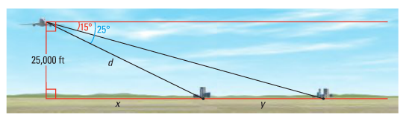
a. What is the distance d from the airplane to the first town?

b. What is the horizonal distance x from the airplane to the first town?

c. What is the distance y between the two towns? Explain the process you used to find your answer.

21.) You measure the angle of elevation from the ground to the top of a building as 32º. When you move 50 meters closer to the building the angle of elevation is 53º. How high is the building?

